Place Making for The Built Environment ABPL90404

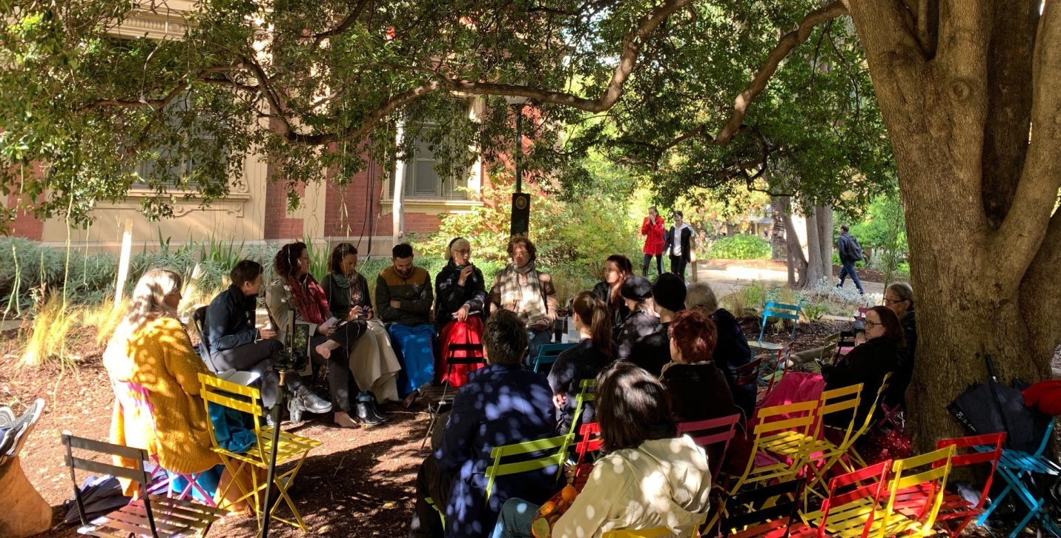
Image: The Living Pavilion a temporary placemaking activity in Melbourne 2019

Day by day subject guide and journal

Day 1 - People in Place: Fundamentals
The Placemaking Fundamentals module introduces students to the general information to placemaking. It is the first or ten days of the subject that collectively aims to support students to build capacities in placemaking. We take a unique approach of using placemaking as a “potential thinking” tool (rather than a problem-based methodology). A tool that can harness the power of the community in shaping and transforming places that people will love.
Image(s) that inspired me today

Journal question 1.1. From your discipline what do you see as your role in creating great thriving places that support stakeholders to have agency? (max 150 words)

References:

Journal question 1.2. How would you define objectives of placemaking at Preston Market? I.e. What is its potential, the people who could be involved? (max 100 words)

References:

Day 2 – Nature in Place
This day will provide students with the background, knowledge and tools for embedding nature in their placemaking practices and approaches. We will discuss the connections between individual and community values for nature, a sense of place created by nature in place, and ultimately how values and sense of place influence wider stewardship of the biosphere.
Image(s) that inspired me today

Journal question 2.1. What will you need to learn from other disciplines so that you can integrate nature into place, into your practice, so it isn’t a consultation but part of what you do and think of? (max 150 words)

References:

Journal question 2.2. How will nature have a voice in the place? (max 100 words)

References:

Day 3 – Site Thinking in Placemaking - There’s No Place Like (Without) Country
Today we will take a personal journey exploring the ideas of diversity and First Nations understanding of place.
“This is not a site, it is a Songline. A connection to the memories of family that have been embedded in this Country and its earth, water, stars and sky since time began. Miluni is the mud that has squelched between the toes of feet that carry our stories and knowledges and miluni brings those memories, our knowledges through time and space to me here today. I do not see a “site”. I feel Country and it welcomes me home.” Shannon Foster, Sydney D’harawal Knowledge Keeper
Image(s) that inspired me today

Journal question 3.1. What has this session taught you about deep listening? (max 150 words)

References:

Journal question 3.2. How will you listen to diversity to inform Preston market? (max 100 words)

References:

Day 4 – Engagement
Community engagement is a fundamental process used throughout the world to attract and involve stakeholders and communities’ opinion and participation in various programs. It can be superficial or ‘deep’. Today we will cover the key tenets and process of doing community engagement are explored using case studies and examples.
Image(s) that inspired me today

Journal question 4.1. Is trans-disciplinarity as integral to engagement? (max 150 words)

References:

Journal question 4.2. How will engagement lead to agency in the stakeholders? (max 100 words)

References:

Day 5 - Government and developers
Local government and developers are key stakeholders in placemaking projects and initiatives. Local government and developers often engage in and support placemaking activities when these projects help them to achieve their various responsibilities in creating, enhancing and managing good quality places and when the activity works within, or extends, their capacity to address their responsibilities. Today we will focus on these responsibilities and capacities of local governments and developers, as a way to understand why they value placemaking
Image(s) that inspired me today

Journal question 5.1. What discipline are developers and council people usually and what does this mean for placemaking? (max 150 words)

References:

Journal question 5.2. How do you engage government and developers to become co-custodians? (max 100 words)

References:

Day 6 – Designing for change
Today we will focus on the application of adaptive design thinking in the context of rapid urban change. We will examine which strategies can be put in place, and how placemaking initiatives can assume a substantial role in urban design, to respond to the complex challenges posed by urban transformations.
Image(s) that inspired me today

Journal question 6.1. Change is often unexpected and complex, how can multiple disciplines working together support thriving through change? (max 150 words)

References:

Journal question 6.2. How will your approach support adaptability of the place and its human and ecological capital? (max 100 words)

References:

Day 7 – digital placemaking – the data and the technology
Today we will critically look at placemaking using digital technology and we will look at ways to collect data about place online. We will use Neighbourlytics as spend some time playing with it for the place where we are working.
Image(s) that inspired me today

Journal question 7.1. To get digital placemaking right what do you need to know and what do you need to be able to draw on? (max 150 words)

References:

Journal question 7.2. How will you use digital placemaking to understand the place? (max 100 words)

References:

Day 8 – Evaluating place
Today we will explore the existing strategies to evaluate place from a socio-ecological perspective and argues that we need to go beyond the easily measurable attributes of place, and have greater inclusion of the intangible benefits of place. This evaluation needs to be across the aspects that are involved in placemaking at four different levels – input, output, outcome and legacy. We will also cover the basics of economics for placemaking.
Image(s) that inspired me today

Journal question 8.1. Evaluation has power, what do you think this is? (max 150 words)

References:

Journal question 8.2. How you will evaluate the success of the market? (max 100 words)

References:

Day 9 – Leadership
Leadership in placemaking requires often assumed skills. The resources available to placemakers typically demonstrate how leaders can implement projects, initiate ideas and run workshops. However, the development of leadership skills and how these can be learnt is not typically discussed. There are many different ways of considering, enabling and implementing placemaking, and the anticipated goals may be different for each of the stakeholder groups. So how do placemakers navigate their way through this complex management process? What are the skills required to enable engaging, effective and successful placemaking for all, or at least most? Leading a team is challenging, and in placemaking, often requires an adaptive, reflective approach.
Today begins with a background on leadership models, before introducing a new framework for leadership in placemaking. Today’s chapter invites you to critically reflect on the case studies presented throughout this book. This reflection is focused on common strategies that are employed, the different types of situations that may arise during a placemaking project, and the skills required to engage with all stakeholders to reach an outcome. Lastly you will learn how to determine your own leadership style and how to keep a leadership reflective journal as a critical tool to enabling you on your placemaking journey.
Image(s) that inspired me today

Journal question 9.1. How will you support the shift in leadership of the Preston stakeholders over time? (max 150 words)

References:

Journal question 9.2. What is your leadership style what does this mean for your placemaking practice? (max 100 words)

References:

Day 10 – case studies and implementation
Today we will spend looking at case studies of placemaking using different placemaking approaches. You will think about the context and purpose of each and think about if they have been successful. We will also spend time looking at the role of art/creative based placemaking.
Image(s) that inspired me today

Journal question 10.1. which case studies inspired you most? (max 150 words)

References:

Journal question 10.2. what is critical in the ongoing expression of the potential of a place? (max 100 words)

References:

Final reflection
The aim of this is to summarize your key learnings and a-has, to reflect what you learnt from the process of presenting and listening to feedback and to think about what this means for your future practice.
My all time favourite image of the subject

Journal question FIN.1 - my key learnings and A-Ha moments

Journal question FIN.2. what did you learn from presenting

Journal question FIN.3. what’s next? What does this mean for your practice

HAND-IN before _______________

